**GENERAL INTEGRATED SCIENCE**

**TASK 7 Test :**

**CYCLES, ecosystems and sustainability**

**NAME: MARKING KEY**

**WEIGHTING: 5 % Total Marks: / 40**

**Multiple Choice Questions** (7 marks)

1. Which of the following is NOT an abiotic factor?
2. Decomposer
3. Wind
4. Humidity
5. Temperature
6. Identify the possible link “A” in the following food chain: Plant 🡪Insect 🡪 Frog 🡪 A🡪 Eagle
7. Cobra
8. Parrot
9. Rabbit
10. Wolf
11. In earth’s ecosystems, energy:
12. is recycled and is never really lost.
13. flows from producers to consumers and back to producers.
14. flow in one direction, from producers to consumers.
15. is produced at all trophic levels of food chain.
16. When water droplets are large enough, to fall from the clouds, it is called
17. condensation
18. transpiration
19. sublimation
20. precipitation
21. In the carbon cycle, both terrestrial and aquatic organisms exchange _________ with the atmosphere.
22. Sugar
23. Oxygen gas
24. Carbon dioxide
25. Methane
26. A consequence of cutting down of forests is
27. that water is no longer returned to the atmosphere over the area of the forest.
28. the loss of animal habitat.
29. the production of high quality agricultural land.
30. all of the above.
31. How are the greenhouse gases believed to be causing the temperature of earth to increase?
32. They allow more solar radiation to pass through to the earth’s surface.
33. They prevent the heat energy from leaving the earth.
34. By absorbing sunlight .
35. By reducing photosynthetic rates .

**Short Answer Questions**

1. The three main spheres that make up our earth are Lithosphere, Atmosphere and Hydrosphere. Write a description of each of the spheres in the space below. (3 marks)

Lithosphere: The lithosphere is the Earth’s crust and the mantle below the crust. OR It includes mountains, continents and ocean floor.

Atmosphere: The atmosphere consists of all the gases that surround the Earth. OR It is composed of Nitrogen, Oxygen, Carbon dioxide and other gases in very small amounts.

Hydrosphere: The hydrosphere is all the water on Earth. It includes oceans, lakes, rivers, ice caps and glaciers.

1. Explain why the atmosphere is very important to maintaining life on Earth? (1 marks)

The atmosphere is vital to life on Earth. It contains Oxygen, reflects and absorbs harmful radiations and keeps the planet warm. (Accept any variations with a similar meaning)

1. On Earth there are many factors that life depends upon. These are referred to as **Abiotic** and **Biotic** factors. In the space below write a description of each of these factors. (2 marks)

Abiotic: Non-living parts physical and chemical parts of an environment which affect organisms.

Biotic: Living parts of an environment which affect organisms.

1. The Emu is a native animal to Australia. There are several factors that affect the Emu during its life. List **one** abiotic and **one** biotic factor that would affect the Emu and give an **explanation** of how they affect the Emu.

(4 marks)

Abiotic factor: Water / sharp objects

Explanation: Emus drink a lot of water (10-20 liters a day) OR ingest sharp objects like metals to grind their food in their digestive system.

Biotic factor: Fruits, plants, insects and lizards OR Dingoes and Eagles

Explanation: Emus eat fruits, plants, insects and lizards OR dingoes and eagles eat emus.

1. Describe what a food chain is? (1 marks)

The path by which energy passes from one living organism to another OR a general description of what happens in a food chain.

Below is a diagram of the food web of a marine ecosystem.

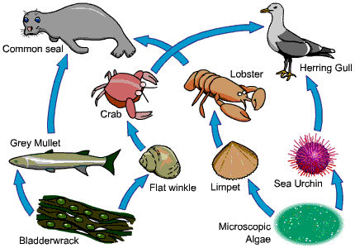

1. Draw a food chain from this food web. (1 mark)

________________ 🡪 ________________ 🡪 _________________ 🡪 __________________

Accept any example from the above food web.

1. Using the food web, write the name of a: Accept any example from the above food web (3 marks)
2. Carnivore __________________________
3. Herbivore __________________________
4. Producer __________________________
5. Primary Consumer __________________________
6. Secondary Consumer __________________________
7. Tertiary Consumer __________________________
8. What do the arrows in a food chain represent? (1 mark)

The arrows represent the flow of energy or direction of consumption of one organism by the next organism in the food chain.

1. A disease has wiped out most of the flat winkle population. Giving an explanation, what will happen to the numbers of: (3 marks)
2. Grey Mullet: Increase + valid explanation according to the diagram
3. Crab: Decrease+ valid explanation according to the diagram
4. Lobster: Decrease+ valid explanation according to the diagram
5. The water cycle describes how water moves from one place to another and changes form from liquid to vapour. Label the six processes that occur in the water cycle on the diagram below. (6 marks)

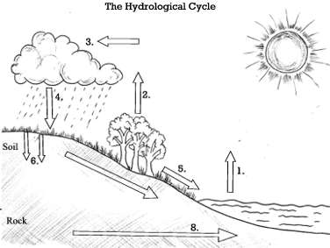

1. Evaporation
2. Transpiration
3. Condensation
4. Precipitation
5. Run-off
6. Percolation
7. -
8. Percolation

(Accept any 6 processes)

1. Explain how trees move water from one storage place to another as part of the water cycle. (1 mark)

During photosynthesis, some excess water evaporates from the surface of the leaves, becoming water-

vapour. The water vapour as a result of transpiration is added to the atmosphere and becomes a part of the water cycle. (Accept any variations of this explanation)

1. Climate change can have a drastic effect on the water cycle. Describe one way that climate change can affect the water cycle. Include how plants and animals would be affected by this change. (3 marks)

Due to climate change, the global temperatures have steadily increased at their fastest rates in millions of years, it’s [directly affected things like water vapor concentrations, clouds, precipitation patterns, and stream flow patterns](http://earthobservatory.nasa.gov/Features/Water/page3.php), which are all related to the water cycle.

Climate change intensifies this cycle because as air temperatures increase, more water evaporates into the air. Warmer air can hold more water vapor, which can lead to more intense rainstorms, causing major problems like extreme flooding in coastal communities around the world.

At the same time that some areas are experiencing stronger storms, others are experiencing more dry air and even drought. Like we mentioned above, as temperatures rise, evaporation increases and soils dry out. Then when rain does come, much of the water runs off the hard ground into rivers and streams, and the soil remains dry. The result? Still more evaporation from the soil and an increased risk of drought.

**(Accept explanations with a similar meaning)- 1mark for one way that climate change is affecting water cycle+ 1mark for how plants are affected+ 1 mark for how animals are affected.**

1. 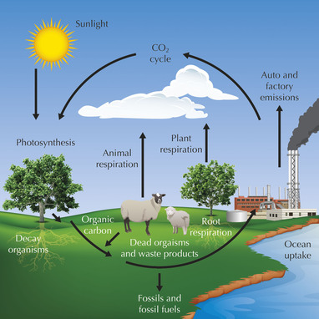

Carbon is a major part of all living things. Explain how carbon gets into living things and how it is then returned to the atmosphere? (4 marks)

* Explanation of how is carbon cycled in the biosphere (2.5 Marks)
* Names of the processes involved like photosynthesis (0.5 Mark), respiration (0.5 Mark), combustion/ burning of fossil fuels (0.5 Mark)